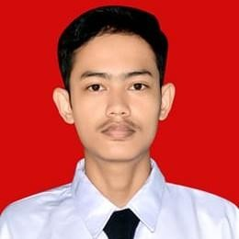KELVIN ADINATA

082368987147 | [kelvinadinata82@gmail.com |](mailto:kelvinadinata82@gmail.com) https:/[/www.linkedin.com/in/kelvin-adinata-b26997229/ |](http://www.linkedin.com/in/kelvin-adinata-b26997229/) https:// github.com/vinwithin

Muaro Jambi, Jambi, Indonesia

I am an Information Systems 5th semester student and Cloud Computing Student at Bangkit Academy 2023 who is committed to developing understanding and skills in the field of web developer. I have skill of for of web development,­ like **HTML, CSS, JS**, **MySQL, PHP, Bootstrap**. and some framework **like Laravel, Hapi.js**. I like working in a team, and enjoy interacting with other people. Always be responsible and have effective communication as my way of achieving success in my future career.

# Work Experiences

**Investree - Jakarta, Indonesia** Jun 2022 - Jul 2022

*Fullstack Developer Internship*

Finishing various task related with the activity of Fullstack Web Developer from Investree Problem solving

Quality Function Deployment,

Php, Sql Database, Restful Api, PHP Framework(Laravel), Authentication,

Code Security,

Optimization & Cleanup Documentation.

# Education

**Universitas Jambi - Indonesia** Aug 2021 - Jun 2025 (Expected)

*Bachelor Degree in Information System, 3.76/4.00*

Coursework : Algorithms; Data Structures; Object-Oriented Programming; Web Programming; Database; Information System Design Analysis;

**Bangkit Academy - Indonesia** Aug 2023 - Jan 2024 (Expected)

*Cloud Computing Student 2023*

Coursework : Algorithms; Rest API, Cloud Computing, Machine Learning Basic, Networking, Web Development, Node.js;

# Organizational Experience

**Information Systems Student Association – Jambi, Indonesia** Aug 2022 - Present

*Member*

Leadership, Responsibility, Time Management, Growth Mindset.

# Skills

* HTML(Intermediate)
* CSS(Intermediate)
* JS(Intermediate)
* PHP(Intermediate)